1RU 1.08Tbps Data Center SWITCH
LN-3548Y-6Z

LN-3548Y-6Z is High performance, multi service aggregation or TOR (Top-of-Rack) switch for telco access, security and cloud, with 6 x 100G/40G（QSFP28）+ 48 x 10G/1GSFP+)
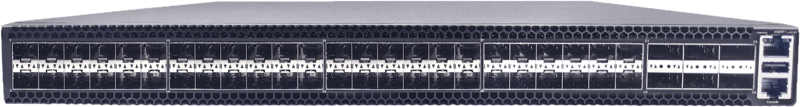
interfaces.

Product Highlights
- 1RU, 19-inch rack mountable design
- Cut-through with ultra-low-latency
- 48 x 10 Gbps (SFP+) ports and 6 x 100 Gbps (QSFP28) ports
- Up to 1.08 Tbps of switching performance
- Open automated configuration and zero-touch provisioning capabilities
- Simplify management of network environments
- Interface flexibility
- Power efficiency

LN-3548Y-6Z switch is an advanced best-in-class, open-source network platform that line-rate L2/ L3 up to 1.08 Tbps switching performance of Marvell Prestera is paired with multi service feature. It is well suited for enterprise access/aggregation, high
bandwidth interconnection for video distribution and security. It can also be used as the cost effective ToR switch for private cloud.
LN-3548Y-6Z is Compact 1RU standard
based open architecture, with redundant power supply & redundant fan modules
The LN-3548Y-6Z switch can be deployed as a top- of- rack (ToR) or leaf switch supporting 10GbE to servers with 100GbE uplinks, each 100G QSFP28 port can be configured 40G as well as 4x 25GbE or 4x 10GbE via breakout cables.

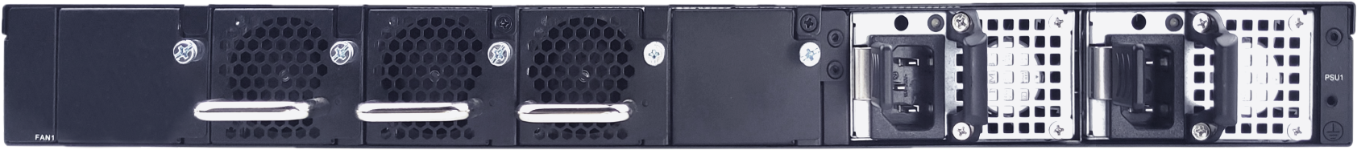
HARDWARE SPECIFICATION
Function/parameter 48x10G +6x100G
Switching Performance | Switch ASIC | Marvell Prestera DX8548
 | Ports | 6 x 100G/40G（QSFP28）+ 48 x 10G/1G（SFP+)
 | Capacity | 1.08 Tbps
 | Packet Buffer | 6MB
CPU  CPU | CPU | Marvell OcteonTX2 CN9130
 | Memory | 4GB DDR4
 | SSD | 32GB eMMC, Optional M.2 SATA slot
CPU  Management Port | USB | 1 x USB2.0
 | Serial Console | 1 x RJ45
 | Management Port | 1 x RJ45 Ethernet 1GBase-T management port
Power | PSU Input | 110V~240V(AC), 36V~72V(DC)
 | PSU Output | 200W/200W (AC/DC)
 | Max. Power Consumption | 130W
Physical and Environmental | Dimensions | HxWxD 440/44/470 mm
 | Rack Space | 1RU
 | Fan | 2+1, hot pluggable
 | PSU | 1+1 hot pluggable
 | Operating Temperature | 0°C to 45°C
 | Operating Humidity | 5% to 90% (non-condensing)
Warranty | Warranty | 1 year
Approvals | Certificate | CCC/CE

Marvell ROS SOFTWARE FEATURES

- MAC-Based VLANs  - Voice VLAN  - Multicast TV VLAN  - Triple Play, MVR  - Q-in-Q, Selective Q-in-Q  - Multicast Bridging Mode  - Static Multicast Groups  - IGMP Snooping  - MLD Snooping  - Flooding of Unregistered Multicast Frames  - Per-device Spanning Tree  - Rapid Spanning Tree  - Multiple Spanning Tree  - STP Root Guard  - BPDU Filtering  - STP BPDU Guard  - Per-device Loopback Detection (LBD)  - LACP  - LAG Balancing  - Static and Dynamics (DHCP/BootP) IP assignment  - DNS Client  - IPv6 Host  - Dual Stack | - ISATAP Tunneling  - MAC-based Port Security (Locked Port)  - 802.1x Port-Based Authentication  - Time Based 802.1x  - Guest VLAN  - Unauthenticated VLANs  - 802.1x - MAC Authentication  - Action-on-Violation  - Flow Monitoring (sFlow)  - RADIUS Remote Authorization and Authentication  - RADIUS Accounting  - TACACS+  - DHCP Snooping  - IP Source Address Guard  - ARP Inspection  - DoS Attack Prevention  - SSL  - SSH  - QoS Across the Stack  - QoS statistics  - Egress Rate Limiting (Shaping)  - Ingress Rate Limiting  - Packet Storm Control  - Dynamic VLAN Assignment

