**100G QSFP28 Passive Direct Attach Copper Cable**

**Description**

The 100G QSFP28 Direct Connect Cable (DAC) is a 4-channel parallel passive copper product for storage, data centers and high-performance computing connections. Each channel is capable of transmitting data at 25Gbps, enabling a 100 Gbps total data rate of 5 meters.

100G QSFP28 to QSFP28 DAC cable for 0.5meters, 1meters, 2meters, 3meters, 5meters are optional.

**Features**

* 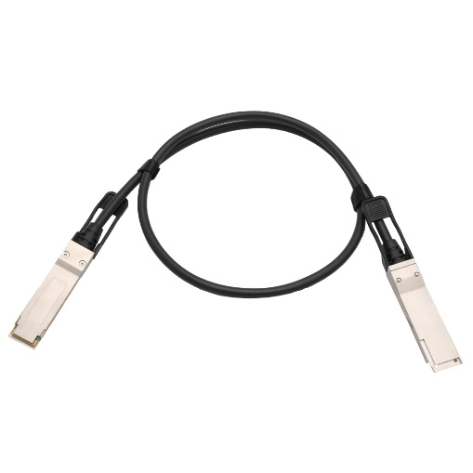Enhanced EMI / EMC performance
* 25Gbps data transfer rate per channel, up to 100Gbps
* Compliant with the IEEE 802.3bj standard and Infiniband EDR specifications
* Meets QSFP + MSA and SFF-8661 / SFF-8665 standards
* Support serial ID function through EEPROM
* 30AWG to 26AWG cable available
* RoHS and halogen-free options

**Applications**

* + Switch / router / HBA / SAN, NIC card
  + 40G / 100G Ethernet
  + Storage, switch, data center, network center
  + Infiniband, QDR / EDR

**Wiring Diagram**

|  |  |  |  |  |  |
| --- | --- | --- | --- | --- | --- |
| **X1** | **X2** | **REMARKS** | **X1** | **X2** | **REMARKS** |
| 18(RX1-) | 37(TX1-) | Pair | 37(TX1-) | 18(RX1-) | Pair |
| 17(RX1+) | 36(TX1+) | 36(TX1+) | 17(RX1+) |
| 15(RX3-) | 34(TX3-) | Pair | 34(TX3-) | 15(RX3-) | Pair |
| 14(RX3+) | 33(TX3+) | 33(TX3+) | 14(RX3+) |
| 6(TX4+) | 25(RX4+) | Pair | 25(RX4+) | 6(TX4+) | Pair |
| 5(TX4-) | 24(RX4-) | 24(RX4-) | 5(TX4-) |
| 3(TX2+) | 22(RX2+) | Pair | 22(RX2+) | 3(TX2+) | Pair |
| 2(TX2-) | 21(RX2-) | 21(RX2-) | 2(TX2-) |
| 1, 4, 7, 13, 16, 19, 20, 23, 26, 32, 35, 38 | 1, 4, 7, 13, 16, 19, 20, 23, 26, 32, 35, 38 | GND | 8, 9, 10, 11, 12, 27, 28, 29, 30, 31 | 8, 9, 10, 11, 12, 27, 28, 29, 30, 31 | EEPROM point at both ends |

**Electrical Characteristics/ Signal Integrity**

|  |  |  |  |  |  |  |  |  |  |
| --- | --- | --- | --- | --- | --- | --- | --- | --- | --- |
| **Item** | | **Requirement** | | | | | | | **Test Condition** |
| Differential Impedance | Cable Impedance | 105+5/-10Ω | | | | | | | Rise time of 25ps (20 % - 80 %). |
| Paddle Card Impedance | 100±10Ω | | | | | | |
| Cable Termination Impedance | 100±15Ω | | | | | | |
| Differential (Input/Output)  Return Loss SDD11/SDD22 | | *{16.5-2√f 0.05≤f*<*4.1}*  Return_loss(f)≥  *{10.66-14log10(f/5.5) 4.1≤f≤19}*  Where f is the frequency in GHz  Return loss(f) is the return loss at frequency f | | | | | | | 10MHz≤f≤19GHz |
| Differential to common-mode (Input/Output)  Return Loss SCD11/SCD22 | | *{22-(20/25.78) f 0.01≤f*<*12.89}*  Return_loss(f)≥  *{15-(6/25.78) f 12.89≤f≤19}*  Where f is the frequency in GHz  Return_loss(f) is the Differential to common-mode return loss at frequency f | | | | | | | 10MHz≤f≤19GHz |
| Common-mode to Common-mode (Input/Output)  Return Loss SCC11/SCC22 | | *Return_loss(f)*≥ 2dB 0.2*≤*f*≤*19  Where f is the frequency in GHz  Return_loss(f) is the common-mode to common-mode return loss at frequency f | | | | | | | 10MHz≤f≤19GHz |
| Differential Insertion Loss  (SDD21 Max.) | | Differential Insertion Loss Max. For TPa to TPb Excluding  Test fixture | | | | | | | 10MHz≤f≤19GHz |
| F  AWG | 1.25GHz | 2.5GHz | 5.0GHz | 7.0GHz | 10Ghz | 12.89Ghz |
| 30(1m) Max. | 4.5dB | 5.4dB | 6.3dB | 7.5dB | 8.5dB | 10.5dB |
| 30/28(3m) Max. | 7.5dB | 9.5dB | 12.2dB | 14.8dB | 18.0dB | 21.5dB |
| 26(3m) Max. | 5.7dB | 7.2dB | 9.9 dB | 11.9dB | 14.1dB | 16.5dB |
| 26/25(5m) Max. | 7.8dB | 10.0dB | 13.5dB | 16.0dB | 19.0dB | 22.0dB |
| Differential to common-mode Conversion Loss-Differential Insertion  Loss (SCD21-SDD21) | | *{10 0.01*≤*f*<*12.89}*  Conversion_loss(f) – IL(f)≥  *{27-(29/22) f 12.89*≤*f﹤15.7}*  Where f is the frequency in GHz  Conversion loss (f) is the cable assembly differential to common-mode conversion loss  IL(f) is the cable assembly insertion loss | | | | | | | 10MHz≤f ≤19GHz |
| MDNEXT (multiple disturbers near-end crosstalk) | | ≥35dB @12.89GHz | | | | | | | 10MHz≤f ≤19GHz |
| Intra Skew | | 15ps/m | | | | | | | 10MHz≤f ≤19GHz |

**Other Electrical Performance**

|  |  |  |
| --- | --- | --- |
| **Item** | **Requirement** | **Test Condition** |
| Low Level Contact Resistance | 70milliohms Max. From initial. | EIA-364-23: Apply a maximum voltage of 20mV  And a current of 100 mA. |
| Insulation Resistance | 10Mohm (Min.) | EIA364-21: AC300V 1minute |
| Dielectric Withstanding Voltage | NO disruptive discharge. | EIA-364-20: Apply a voltage of 300VDC for 1minute between adjacent terminals  And between adjacent terminals and ground. |

**Environmental Performance**

|  |  |  |
| --- | --- | --- |
| **Item** | **Requirement** | **Test Condition** |
| Operating Temp. Range | -20°C to +75°C | Cable operating temperature range. |
| Storage Temp. Range  (In packed condition) | -40°C to +80°C | Cable storage temperature range  in packed condition. |
| Thermal Cycling Non-Powered | No evidence of physical damage | EIA-364-32D, Method A, -25 to 90C, 100 cycles, 15 min. dwells |
| Salt Spraying | 48 hours salt spraying after shell  corrosive area less than 5％. | EIA-364-26 |
| Mixed Flowing Gas | Pass electrical tests per 3.1 after  stressing. (For connector only) | EIA-364-35 Class II, 14 days. |
| Temp. Life | No evidence of physical damage | EIA-364-17C w/ RH, Damp heat 90℃ at 85% RH for 500hours then return to ambient |
| Cable Cold Bend | 4H, No evidence of physical damage | Condition: -20℃±2℃, mandrel diameter is 6 times the cable diameter. |

**Mechanical and Physical Characteristics**

|  |  |  |
| --- | --- | --- |
| **Item** | **Requirement** | **Test Condition** |
| Vibration | Pass electrical tests  per 3.1 after stressing. | Clamp & vibrate per EIA-364-28E, TC-VII, test condition letter – D, 15 minutes in X, Y & Z axis. |
| Twist | No evidence of physical damage | Twist cable 180° (±90° from nominal position) for 100 cycles at 30 cycles per minute with a 0.5kg load applied to the cable jacket.  Clamp position: 300mm |
| Cable Flex | No evidence of physical damage | Flex cable 180° for 20 cycles (±90° from nominal position) at 12 cycles per minute with a 1.0kg load applied to the cable jacket. Flex in the boot area 90º in each direction from vertical. Per EIA-364-41C |
| Cable Plug Retention in Cage | 90N Min.  No evidence of physical damage | Force to be applied axially with no damage to cage. Per SFF 8661 Rev 2.1  Pull on cable jacket approximately 1 ft behind cable plug. No functional damage to cable plug below 90N.  Per SFF-8432 Rev 5.0 |
| Cable Retention in Plug | 90N Min.  No evidence of physical damage | Cable plug is fixtured with the bulk cable hanging vertically. A 90N axial load is applied (gradually) to the cable jacket and held for 1 minute. Per EIA-364-38B |
| Mechanical Shock | Pass electrical tests  Per 3.1 after stressing. | Clamp and shock per EIA-364-27B, TC-G, 3 times in 6 directions, 100g, 6ms. |
| Cable Plug Insertion | 40N Max. (QSFP28) | Per SFF8661 Rev 2.1 |
| Cable plug Extraction | 30N Max. (QSFP28) | Place axial load on de-latch to de-latch plug.  Per SFF8661 Rev 2.1 |
| Durability | 50 cycles, No evidence of physical damage | EIA-364-09, perform plug &unplug cycles: Plug and receptacle mate rate: 250times/hour. 50times for module (CONNECTOR TO PCB) |

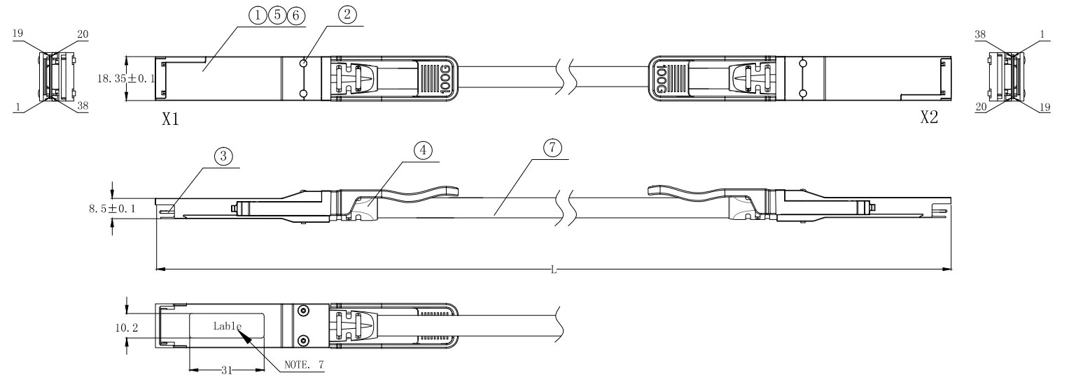**Outline Dimensions (mm)**